Kelly Kauffman

September 9, 2020

IT FDN 110: Introduction to Programming: Python

Assignment 09

Assignment 09:

# Final Products

Here is the link to the final code for Assignment 09 on Github:

<https://github.com/pythongal6295/Assignment_09.git>

Below, Figure 1, 2, and 3 show my code working in Spyder. Figure 4 and 5 show my code working in the Anaconda Prompt.

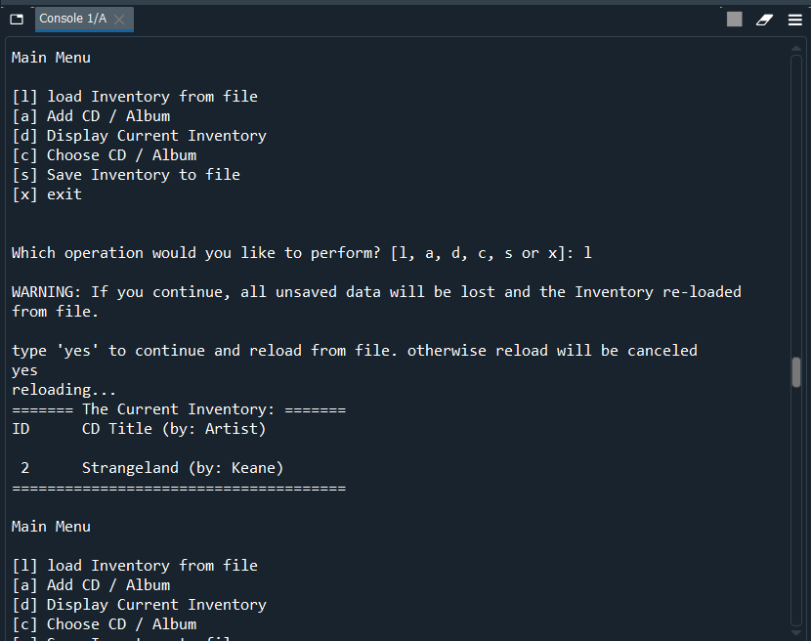

Figure Assignment 09 working in Spyder, part 1

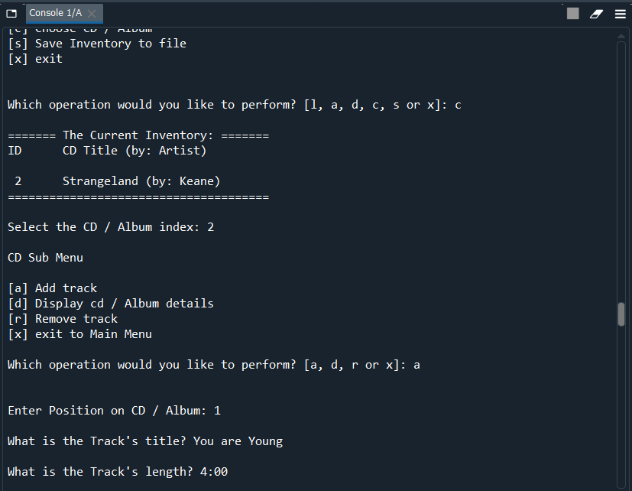

Figure Assignment 09 working in Spyder, part 2

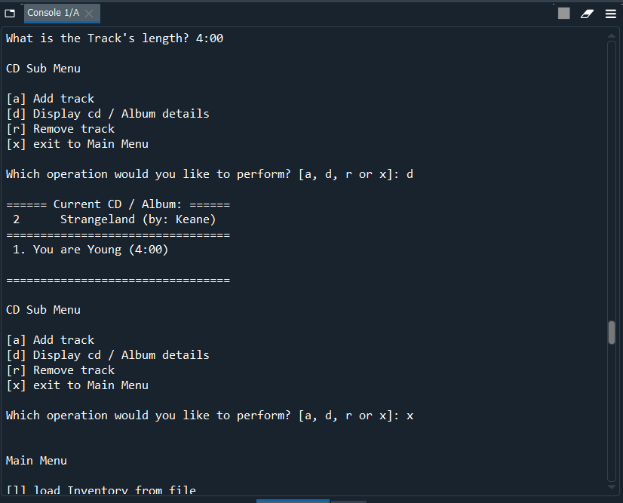

Figure Assignment 09 working in Spyder, part 3

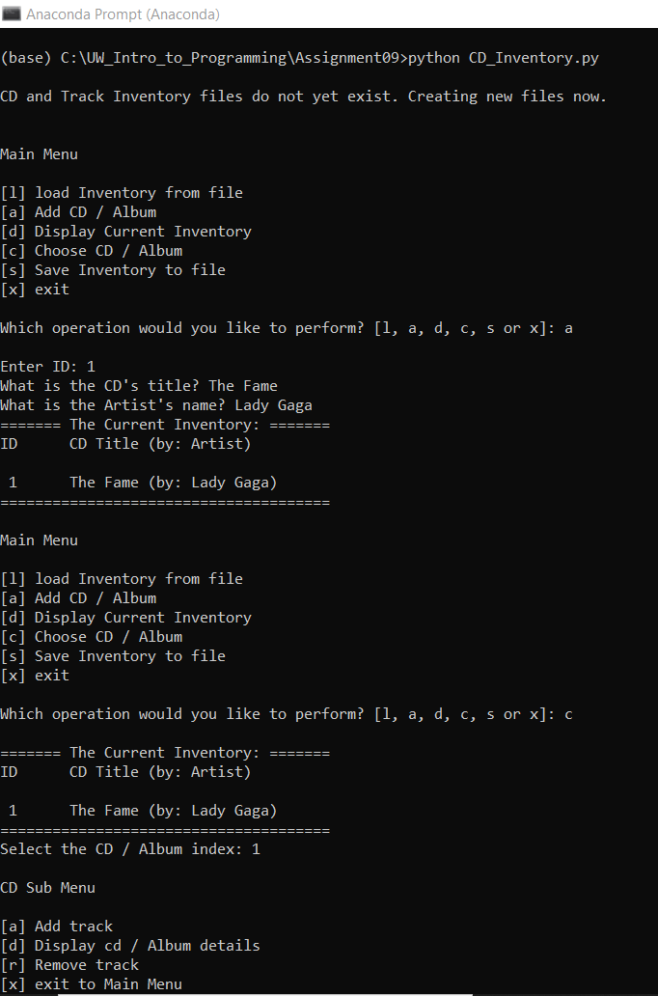

Figure Assignment 09 working in the Anaconda Prompt, part 1

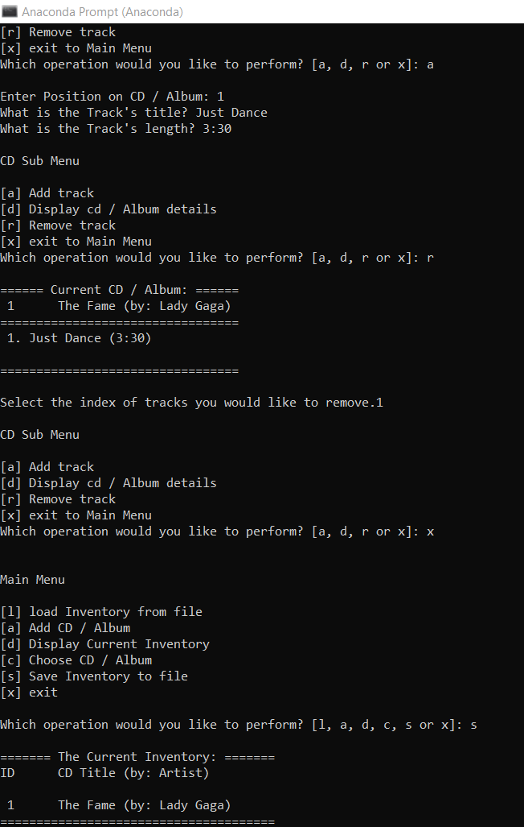

Figure Assignment 09 working in the Anaconda Prompt, part 2